STATEMENT OF PURPOSE
2026/2027
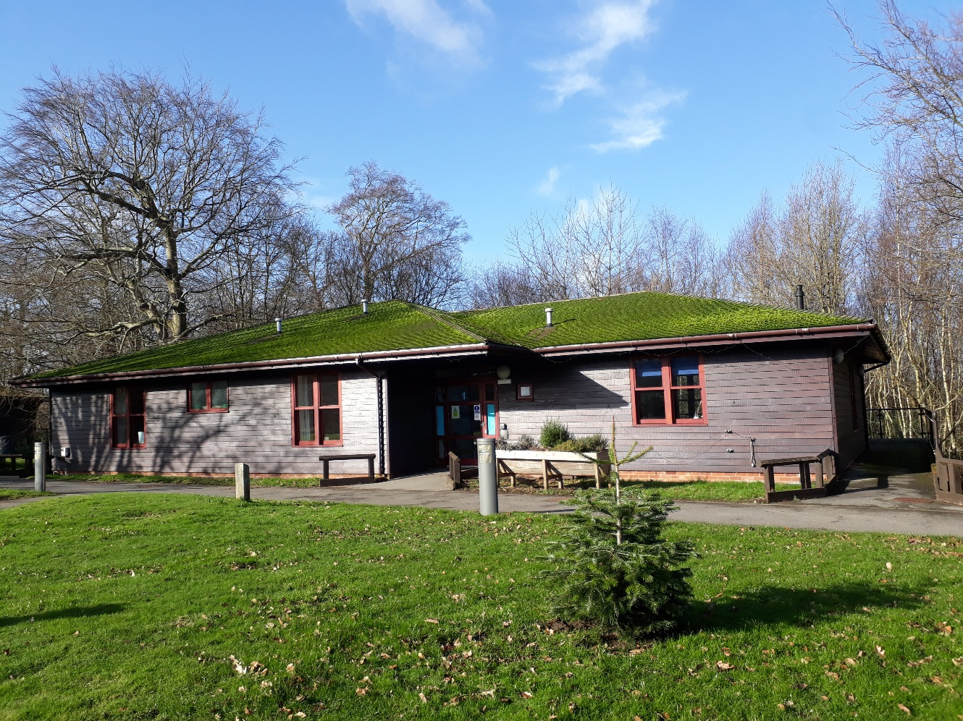

CONTENTS
INTRODUCTION 3
AIMS AND OBJECTIVES 4
OUR VISION 5
CARING FOR OUR CHILDREN & YOUNG PEOPLE 6
SCHOOL CURRICULUM – LEARNING PATHWAYS 7
STAFFING STRUCTURE 8
RESIDENTIAL EDUCATION PROVISION 9
ACTIVITY & LEISURE PROGRAMME 12
Preparing for Adulthood (PfA): 12
CULTURE & RELIGION 14
CONTACT WITH FAMILY & FRIENDS 14
ADVOCACY 15
COMMUNICATION 15
RESIDENTIAL KEYWORKERS 16
STUDENTS’ VOICES 16
STUDENT HANDBOOK 16
EQUALITY, DIVERSITY AND INCLUSION 16
SAFEGUARDING 17
PREVENTING BULLYING 17
DEALING WITH A COMPLAINT 17
SUPPORTING SPECIAL EDUCATIONAL NEEDS 18
STUDENTS & TECHNOLOGY 19
POSITIVE BEHAVIOUR 20
REP STAFF STRUCTURE 21
HEALTH & THERAPY TEAMS 22
THE NURSING TEAM 22
THE THERAPY TEAM 23
OUTREACH SERVICES AND CLINICS 23
OUR STAFF – QUALIFICATIONS & TRAINING 24
REP MANAGER 24
STAFF TRAINING & SUPERVISION 25
CONTACT DETAILS 27
KEY STAFF CONTACT DETAILS 27

INTRODUCTION
Valence School is a vibrant and friendly school which caters for children and young people with physical disabilities and complex medical needs, aged 4-19 years old.
We are a Foundation Special School in the maintained sector and part of the Kent SEN Trust, a cooperative trust of ten schools working together to improve outcomes for children and young people.
Set in the beautiful Kent countryside in Westerham, located just off the A25, Valence School has large, extensive grounds and a broad range of high-quality teaching, social care, and healthcare facilities.
We offer day and boarding places and a team of over two hundred staff provide an exciting and friendly environment for our students to be in. Our dedicated staff provide specialist teaching, social care, therapies and nursing care to an exceptionally high standard, enabling our students to have the best opportunity to achieve their aspirations.
Valence School always places student welfare at the centre of decision making. We are determined to achieve the best possible outcome for our students.

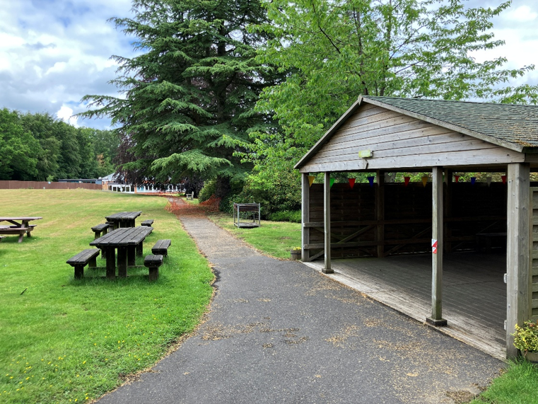

AIMS AND OBJECTIVES

Aims: What we aspire to do | Objectives: How we will achieve these aims
Enable meaningful independence | Support students to develop life skills, functional communication, mobility, and self-care abilities.
Provide a stimulating, supportive environment | Offer personalised academic, residential, and therapy-based support tailored to each student’s needs.
Promote student welfare and safety | Ensure safeguarding, medical, and nursing care are integrated into daily routines.
Prepare students for adulthood | Develop skills for higher education, employment, independent living, and community participation, using the PfA framework
Foster respect, resilience, positivity, and passion | Encourage students to respect others, persevere through challenges, focus on strengths, and explore interests.
Encourage student voice and participation | Involve students in decisions about their learning, residential life, and activities using accessible communication methods.
Support holistic learning | Integrate therapies (speech, occupational, physiotherapy) and care into academic programmes on an individual basis.
Promote equality, diversity, and inclusion | Provide an environment free from discrimination, ensuring all students’ cultural, religious, and personal needs are respected.
Develop positive behaviour and relationships | Use proactive strategies, positive reinforcement, and personalised behaviour support plans.
Engage families and external agencies | Work collaboratively with parents, carers, and professionals to ensure student progress and well-being.
Offer enriching residential experiences | Provide flexible boarding, stimulating activities, offsite trips, and a safe, homely environment in accessible bungalows.
Ensure continuous improvement | Regularly monitor feedback, reviews, and risk assessments to improve student outcomes and residential provision.

OUR VISION
Our vision at Valence School is to provide all students with a learning pathway that meets their intellectual, physical, social, and emotional needs. By working together with families and support agencies, we ensure that students are valued, supported, and challenged to do their best in preparation for the next stage of their learning and life in modern Britain.
At Valence School, we are proud of our school ethos:
- Respectfulness – Valence students respect the rights, needs and views of others. They seek to create an environment where support for each other is commonplace, and everyone feels that they belong.
- Resilience – Valence students take risks and view failure as positive for personal growth. They are encouraged not to give up easily and always try their best.
- Independence – Valence students oversee their own learning. They are provided with a wide range of support to enable independence in everything that is required of them.
- Positivity – Valence students focus on what they ‘can do’ to develop as an individual and not what they ‘cannot do’ because of their disability.
- Passion – Valence students are encouraged to find and develop their own range of interests and to express themselves as they wish, in support of their learning.

Students are rewarded with merits and praise postcards when staff identify our school ethos being demonstrated.
Our school participates in termly interhouse competitions and a variety of other school activities, which contributes to our ethos and house system. Students are allocated one of our four houses to represent: Chartwell, Hever, Quebec or Squerryes.

Staff create a calm, predictable and emotionally secure environment. Their warm, patient and reassuring approach helps students to feel safe and able to express themselves.

Ofsted Inspection March 2026

CARING FOR OUR CHILDREN & YOUNG PEOPLE
Our aim at Valence School is to enable every child and young person to achieve meaningful independence. Our students flourish in a challenging environment, in which we offer excellent support to enable them to achieve functional communication, mobility and skills for daily living.
Due to the complexity of their disabilities and health needs, our teams of experts adopt a multidisciplinary approach by integrating therapy and care into our academic curriculum on an individual, bespoke basis, which includes:
- Communication skills.
- ICT and technology skills.
- Power wheelchair assessments & driving skills assessments.
- Specialist eating and drinking programmes.
- Medical and nursing cover.
- Personalised physiotherapy, speech therapy and occupational therapy with regular sessions with a trained therapist.

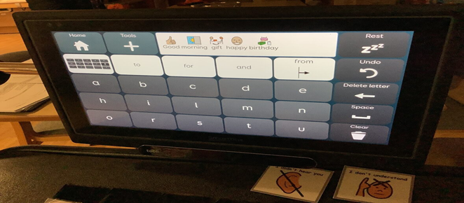

SCHOOL CURRICULUM – LEARNING PATHWAYS

Valence School provides students with a broad curriculum pathway that meets their intellectual, physical, social, and emotional needs. We believe that achievements and outcomes for our students are not related to their age but should be set against their needs and individual goals.
Working together with families and a wide range of support agencies, each student is valued, supported, and challenged to do their best.
Students make evident progress in their confidence, independence and social skills.

Ofsted Inspection March 2026

Our curriculum approach:
- (EYFS) FOX
Students develop a sense of security in the school environment, establish positive relationships with familiar adults, explore the world using their sensory and physical capabilities and establish behaviours through which they can communicate.
- Primary: Owl, Rabbit, Hedgehog and Deer
- Pre-Formal – Keller class
Students develop on the ImPACTS curriculum, with individual targets focusing on communication, cognition, physical skills, as well as personal, social, emotional and independence targets.
- Semi-Formal – Simmonds classes
Students achieve best when learning is related to their own experience through structured exploration, functional activities, or a topic-based approach. In KS2 and KS3, the curriculum content corresponds to the National Curriculum. The assessment system focuses on an individual student’s EHCP outcomes and short-term targets, which measures their progress over time.
Independence is an important part of the timetable to help students experience and embed important life skills for the future.
- Formal – Hawking classes
Students access a range of National Curriculum subjects modified for their special educational needs. There is a high level of structure and learning is linked to activities which are consolidated and applied in practical sessions.

STAFFING STRUCTURE – SEMPTEMBER 2026

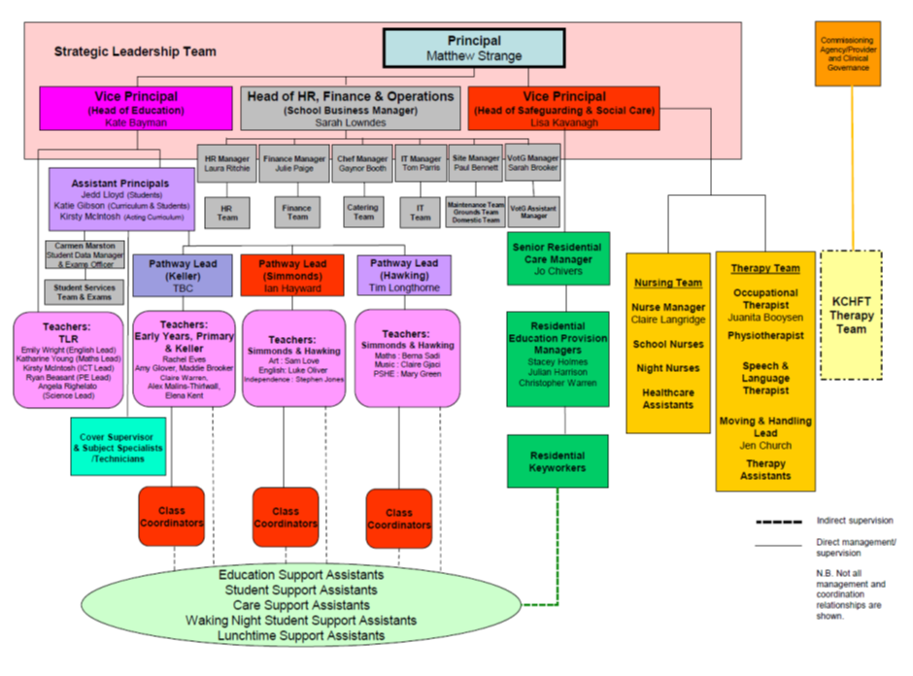

RESIDENTIAL EDUCATION PROVISION
The residential provision at Valence School compliments the daily life of the school by creating a stimulating environment to encourage children to develop their emotional, intellectual, social, creative, and physical skills.
To ensure a smooth and successful transition into adulthood, our residential offering enables students to develop their independence and prepare them for future independent living, higher education, employment, and community inclusion.
Our accommodation consists of eight bungalows arranged into home living areas (HLAs) to create a welcoming and homely atmosphere for our students, so that they feel safe, comfortable and their privacy is respected.
Our bungalows are designed to meet the needs of our young people and are fully accessible with height adaptable kitchen and bathroom fixtures and fittings. Remote activation of facilities enables students to adapt their environment according to their needs.
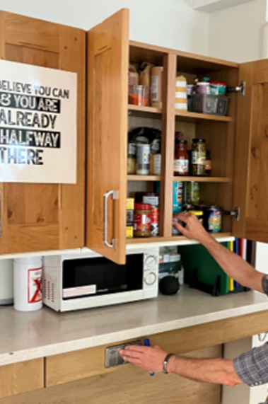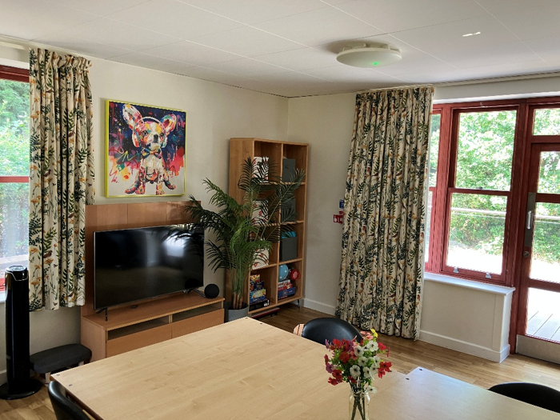

Each Bungalow has its own Manager, and team of dedicated staff who are trained to meet the needs of the young people they support. A Residential Educational Provision Manager is on shift throughout the evening, working with the Student Support Assistants and Keyworkers.
Prior to boarding, an assessment of their needs is completed by visiting their home, so we can provide the best possible ‘home from home’ experience for them.

Families feel involved in their child’s care and value the strong relationships and clear communication from staff. One parent said, ‘I don’t know if my child would have survived without them.’

Ofsted Inspection March 2026
Every student has their own room or shares with one other student. They can express a preference about who they share with, and students are encouraged to personalise their room with posters, photos, and soft furnishings.
The spacious communal living areas enable students to socialise and relax after a day at school, and each bungalow is equipped with a TV (Disney+, Netflix & NOW TV), a Wii and a PlayStation games console.
Student’s meetings are held per term for each Bungalow and provide a valuable and safe environment for students to discuss what is happening in the world.
There is a close link between the REP team and Pathway Lead, which includes providing support with homework and linking evening activities with curriculum plans.
Support is provided to enable young people to participate in as many home living tasks as possible, such as laying the table for meals, emptying the dishwasher, and collecting towels from the laundry room.
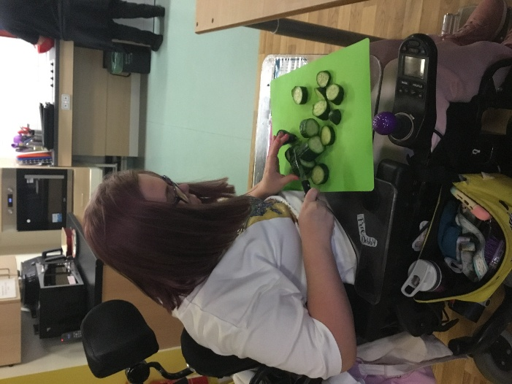

Our students are actively encouraged to make choices and to contribute their views in how their living area is run.
Weekly meetings are held to plan menus and activities together.
There is a cooking schedule, and students have the opportunity to go and buy their shopping and be involved in the preparation and cooking of their meals.

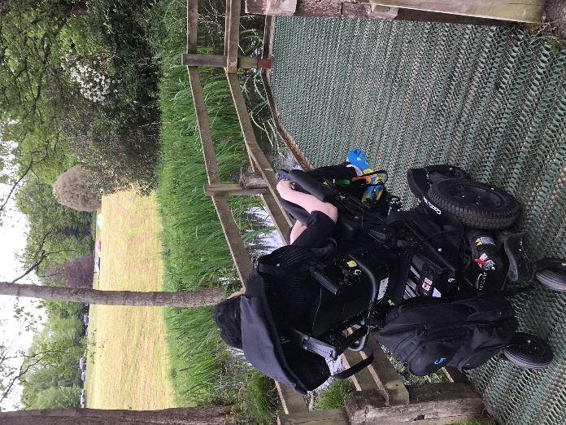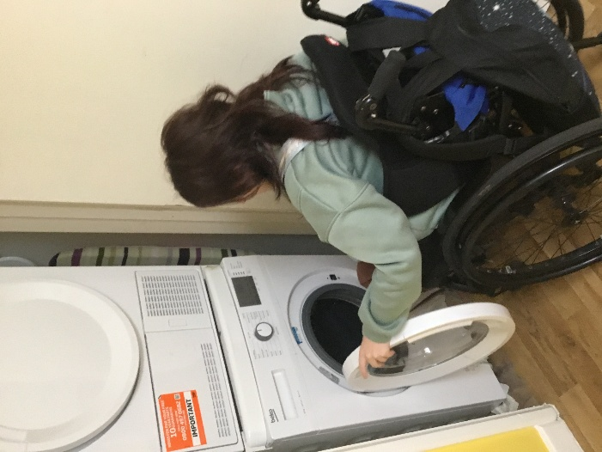

Our students are proactively engaged and supported in a wide range of positive activities that contribute to their physical, emotional, and mental health.
We have a stimulating activity and leisure programme which responds to the individual needs, interests, and preferences of our students. There are many opportunities to take part in recreational pursuits offsite, such as: shopping, concerts, sports fixtures, days out in London, museum visits, bowling and cinema and ice-skating trips.
Onsite seasonal and themed parties and events regularly take place and a Leavers’ Prom is held each summer.

ACTIVITY & LEISURE PROGRAMME
A variety of activities are available every evening: alongside alternative student’s choice.

- Physical Management, Sensory spa sessions, Cooking, Drama Group focusing on PfA Games night, Fitness club, Karaoke
Students also take part in offsite trips of their choice these are often birthday trips, bowling, ice skating, shopping or meal out with friends

Preparing for Adulthood (PfA):
Preparation for Adulthood is a key aspect of residential life at Valence School and is embedded throughout students’ daily experiences. Residential staff work alongside education and therapy teams to provide meaningful opportunities for students to develop the skills, knowledge and confidence required for adult life.
In line with the Preparing for Adulthood framework, students are supported to develop independence, employability skills, community participation, and the ability to maintain their own health and wellbeing. Through planned activities and everyday experiences, students learn money management, home and personal safety, healthy eating and nutrition, travel and community skills, online safety, understanding relationships and personal responsibilities, mental health and wellbeing, and how to manage their own healthcare needs.
Students are encouraged to make choices, develop self-advocacy skills, and take increasing responsibility for their daily living routines. This personalised approach supports successful transitions into adulthood and enables students to lead safe, fulfilling and meaningful lives within their communities. The students take part in various other activities throughout the year, we have in house competitions, best dressed bungalows during Halloween, Gingerbread house making, guy Fawkes competition and many more.

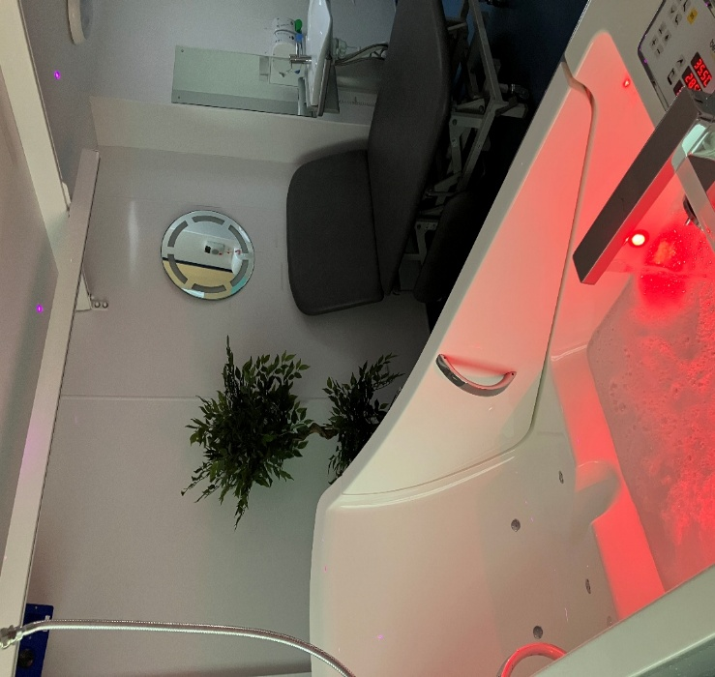
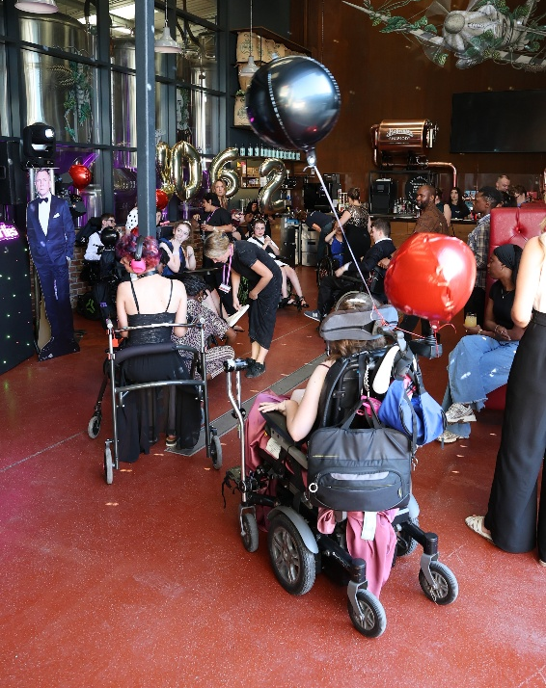

CULTURE & RELIGION
All children and young people have the right to their religious, personal, and cultural beliefs. Our students’ preferences are recognised and respected at Valence School. During the admission process, our students and their families are consulted about their beliefs and support is offered to enable them to express these beliefs during their time at school.
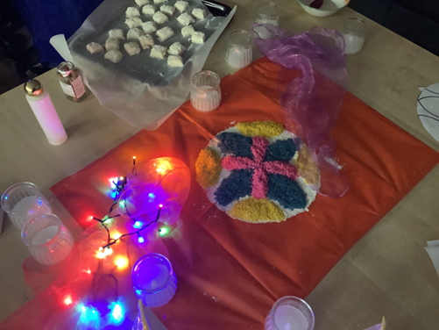

CONTACT WITH FAMILY & FRIENDS
Students stay in contact with their families and friends during their stay in our accommodation in a variety of different ways. They have access to a speaker telephone, a computer to access the internet and send and receive emails, an iPad as well as their own devices. There are dedicated areas within the bungalows to make calls which give the students privacy.
Parents and carers are encouraged to attend coffee mornings and participate in the Friends of Valence group, run by parents, which can offer support, encouragement, and a chance to share information. Students are provided with details of child specific support services, such as Childline to contact in case of problems or distress.

Feedback from parents and professionals is consistently positive. Families feel involved in their child’s care and value strong relationships and clear communication from staff.

Ofsted report 2026

ADVOCACY
A former pupil acts as an Independent Advocate for our students. Visiting the bungalows regularly, he is a valuable point of contact for students who wish to talk to someone independent yet is also familiar with Valence School.
Our advocate is easily accessible at reasonable times and knows the children. He interacts and communicates effectively with the students and can recognise safeguarding concerns. Students who cannot communicate verbally are given the means to request individual support when communicating with him.
Students are provided with appropriate advocacy support where necessary and are aware of what services are available, how they may access that support and any entitlement they may have to advocacy provision.

COMMUNICATION
Working with our speech and language therapists, our residential team ensure that our students have access to communication systems such as VOCAs, communication books and specially designed communication devices such as Eye Gaze. We have BSL and Makaton trained members of staff. Our staff also receive training from therapists in how to access and input new words and information for the students’ VOCAs.

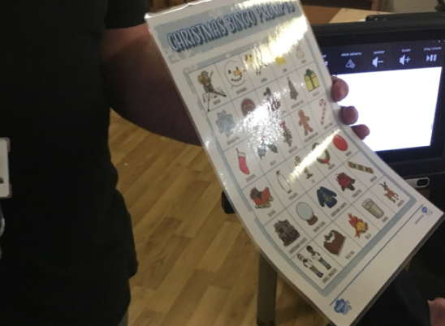

RESIDENTIAL KEYWORKERS
Each student has a keyworker assigned to them for dedicated support. The keyworker develops a close working relationship with their student, providing moral support and someone to talk to, as well as working on areas they would like to develop.
Keyworkers develop nurturing relationships with students to support their emotional needs while respecting their rights and dignity. They have the skills and knowledge to recognise their student’s individual healthcare needs and act appropriately.
The keyworker coordinates with colleagues across the school to ensure a consistent approach to their student’s support. They are responsible for maintaining communication with the student’s family or carer.


STUDENTS’ VOICES
Students’ opinions are actively sought using methods appropriate to their level of understanding and communication needs.
Active steps are taken to enable all children to make their views known about their residential experience.
Seeking the views of our students and their families is important and we regularly provide short questionnaires to gain feedback to ensure student needs are being met.
Student questionnaires are presented in an accessible format, and support is given from staff to fill them in when required.
The Head of Safeguarding & Social Care and the Residential Manager review the responses and resolve any concerns quickly and implement areas of improvement where possible.

STUDENT HANDBOOK
A Student Handbook is given to each young person before they start boarding at Valence School. It offers all the information they require to make a confident start to Valence School and to support them during their stay with us.

EQUALITY, DIVERSITY AND INCLUSION
An inclusive environment is promoted at Valence School to ensure that no student is discriminated against because of their cultural background, linguistic background, special educational needs, or academic or sporting ability.
Our commitment to equality of opportunity and the elimination of discrimination extends to all applicants, students, parents, staff, governors, trustees, contractors, volunteers, and visitors.

SAFEGUARDING
We take the welfare of our students extremely seriously. Valence School has designated safeguarding leads (DSLs) who are fully trained to look after and promote the health, safety, and welfare of our students.
Children are safe in the school’s residential accommodation and measures are taken to manage risk and protect students from harm and to manage any incidents that do occur.
Valence School ensures that all staff are aware that safeguarding and promoting the welfare of children is everyone’s responsibility throughout the school and its residential facilities. All staff are trained in safeguarding children and whistleblowing, enabling them to respond to concerns and be accountable for their working practices.
All concerns are reported via our online system CPOMS. Risk assessments are completed to ensure all potential dangers are identified. There are posters across the school site with relevant information and the contact details of all DSLs.
Any student who discloses abuse will be listened to and fully supported. We have a strict policy of openness and zero tolerance over abuse and neglect, so when problems arise, we may report concerns to Kent County Council or Ofsted. We will always speak to parents/carers about concerns whenever possible.

PREVENTING BULLYING
Valence School is committed to providing a caring, friendly, and safe environment for all students so they can achieve their full potential.
The school ensures that all forms of bullying are prevented as far as reasonably practicable by the implementation of an effective anti-bullying strategy, which includes accessible and effective systems for children to report bullying.
Staff and children understand that bullying is unacceptable and not tolerated at Valence School. If bullying does occur, we ensure students know what to do and they are encouraged to communicate with a trusted member of staff. Any claims of bullying, discrimination, aggression, and derogatory language are dealt with promptly and effectively and staff take steps to help children overcome the impact of bullying.
We take part in the annual anti-bullying week and have themed assemblies and lessons where students can learn about anti-bullying, safeguarding, and e-safety.

DEALING WITH A COMPLAINT
Valence School aims to offer an excellent service to its students, however, on occasion when a complaint is made, we take all concerns seriously. We have a thorough, effective complaints policy with clear guidelines on recording and responding to complaints and timescales for responses.
Most issues can be dealt with informally, but if not, we will instigate a formal investigation.
Any complaint is recorded and sent to the headteacher for their attention. We then have different channels we can take the complaint: local resolution, investigation, governor review or SoS Complaints Unit.
Parents and carers are clear on how to make a complaint, how it will be dealt with and the timescales for a response.
If our students are feeling worried or upset, we ensure that they know how to complain and to whom to complain. There are posters around the school buildings encouraging students to talk to someone they feel comfortable with, and their concerns are always addressed quickly and fairly.
The school has a clear and easily accessible process for children to raise their own complaints about residential provision and is clear about how it will respond to complaints from children and allow for different communication needs. The students’ understanding of our complaints policy is regularly reinforced.
We always endeavour to learn from any incidents and develop the quality of our service.

SUPPORTING SPECIAL EDUCATIONAL NEEDS
Each student has a support plan and input from the student, and their parent/carer is sought before creating the document. Support plans are kept updated as targets are achieved, require review or when there are significant changes. Annual Reviews and MDT meetings with parents/carers provide an opportunity to discuss Education Health and Care Plans (EHCP) with the staff team.

STUDENTS & TECHNOLOGY
Students have access to a wide range of technology and will have a technology assessment when they start. They have a dedicated PC set up specifically for their requirements. Individual IT requirements are regularly reviewed and modified as appropriate.
Wi-Fi access is found across the school site, including the home living areas. Online safety is of paramount importance and is integrated into the curriculum. Appropriate internet access is provided for the purposes of organised and private study outside school hours and for social purposes.
All students have an email address and are supported in their understanding of online safety and potential risks of using the internet.
Students and parents are asked to sign the Acceptable Use of Technology Policy.



POSITIVE BEHAVIOUR
Positive reinforcement of good behaviour is our primary method of managing behaviour. The holistic support we give to students – in terms of their emotional wellbeing, communication and understanding of their impact on others – promotes positive behaviour. Individual Positive Behaviour Support Plans are produced for students and staff teams as required and include strategies and appropriate consequences.
Communication with and involvement of the young person and their family is essential.
Children are supported to develop good relationships with fellow pupils and staff. Positive behaviour and good relationships are encouraged and praised. Any sanctions for misbehaviour are well understood and implemented fairly.
Staff receive appropriate training and support to recognise and deal with incidences of challenging behaviour.
Many of our students require physical prompts to enable them to experience and learn new skills and concepts. All our students require physical assistance from staff within clear boundaries. Physical intervention to manage more significant behaviour will only be taken: -
- To prevent risk of harm to student or staff.
- To prevent significant damage to property.
- To prevent criminal acts or maintain good order.
For our students, physical intervention may also result in the power being turned off from their power chairs.
Verbal prompts will always be given initially to encourage a student to modify their behaviour.
Each incident of physical restraint/intervention is logged in a book which is kept in the reception area and reviewed by the senior managers / DSL within 24 hours. The school staff have regular approved training with Team Teach.
For further information, please refer to Valence School’s Behaviour Policy

REP STAFF STRUCTURE

VICE PRINCIPAL
HEAD OF SAFEGUARDING & SOCIAL CARE

RESIDENTIAL CARE MANAGER

REP MANAGERS

RESIDENTIAL KEYWORKERS

STUDENTS SUPPORT ASSISTANTS

HEALTH CARE ASSISTANTS
WAKING NIGHT STAFF

HEALTH & THERAPY TEAMS

Kent Community Health NHS Foundation Trust (KCHFT) provide Special Schools Nurses and Therapists within Valence School, to support students with complex needs in accessing their education.
Working in partnership, the health and therapy teams empower the school staff to support the care and therapy of students.
Valence School has effective links with health agencies, including specialist services where appropriate, and secures these services for students when required.
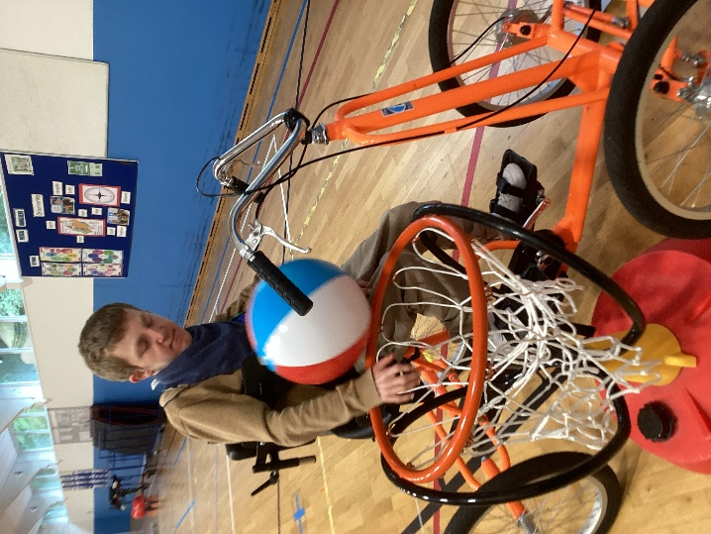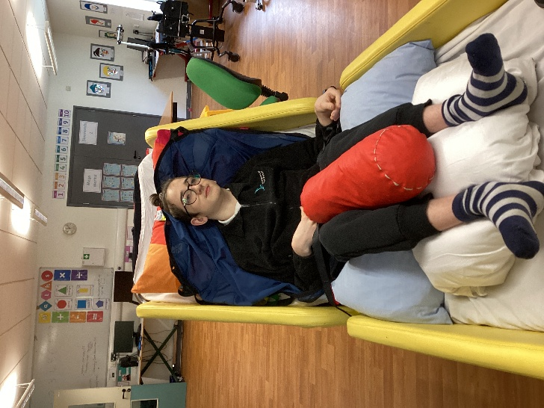

THE NURSING TEAM
Our team of qualified nurses have a wealth of specialist knowledge, skills, and expertise of working in special schools and supporting children and young people with their health needs. The nursing team assesses students with more complex needs and ensures school staff are trained and equipped to care for them. They provide support during and beyond the school day.

THE THERAPY TEAM
Our therapy team of qualified, HCPC registered physiotherapists, occupational therapists, and speech & language therapists have specialist knowledge, skills, and expertise of working in special schools. The team also includes experienced therapy assistants.
The NHS therapy team based at Valence School aims to provide personalised and holistic care for each student. Their intervention is aimed at supporting students in accessing the curriculum and is implemented into students’ learning.

OUTREACH SERVICES AND CLINICS
Where appropriate, members of our multidisciplinary therapy and health team may refer students to outreach services such as:
- Specialist Teaching and Learning Service (STLS) for Visual Impairment.
- Specialist Teaching and Learning Service (STLS) for Hearing Impairment.
- Wheelchair services.
- AAC hubs (Kent CAT team).
- Community Paediatrician.
- Immunisation Teams
- KCHFT provide Occupational Therapists, Physiotherapists and Speech & Language Therapists.
- Consultant clinics.
- Dysphagia Team.
- Additional tertiary medical services.
Consent will be sought and where possible these services will be accessed through on-site appointments.

OUR STAFF – QUALIFICATIONS & TRAINING
VICE PRONCIPAL (SAFEGUARDING & SOCIAL CARE)
The Vice Principal is a qualified Social Worker, with over 11 years’ experience as a Registered Manager for KCC Short Breaks, prior to joining Valence School.
Qualifications: BA Social Work (England)
Level 5 Management & Leadership (CMI)
Level 4 Residential Childcare
Level 3 Children & Young People
Training: Team Teach Intermediate Tutor
Designated Safeguarding Lead
First Aid at Work
Fire Safety
Epilepsy / Emergency Medication
Moving & Handling
Safer Recruitment

RESIDENTIAL SERVICE MANAGER
With more than 41 years’ experience in social care, The Residential Service Manager has worked at Valence School for almost 22 years coordinating care and support.
Qualifications: NVQ in Health and Social Care Level 3
Diploma Level 5 in Leadership Management.
Training: Designated safeguarding lead
Team Teach Intermediate Tutor
Safer Recruitment
First Aid
Fire Warden
Epilepsy / Emergency Medication

The Residential Education Provision (REP) Managers hold a Diploma Level 5 in Health and Social Care and/or Leadership and Management for Residential Care.
All Residential Keyworkers are working towards or have obtained their Diploma Level 3 in Health and Social Care.
All new staff hold at least a relevant minimum Level 3 qualification or will begin to work towards it within three months of confirmation of employment at Valence School, with the aim to complete the qualification within two years.

STAFF TRAINING & SUPERVISION
Our staff are well trained, experienced, and skilled and have been vetted to ensure their suitability to work at Valence School. They are up to date with professional, legal and practice developments and the policies and legal obligations of the school.
We aim to develop our REP staff to their full potential, with the appropriate skills to meet the needs of our children and young people resident in the school.
Our staff complete their comprehensive mandatory training within their first year at Valence School and complete the CWDC Induction Standards in preparation for achieving their Level 3 Diploma.
All staff undertake an induction programme designed to enable them to meet the range of needs of children at the school and fully equip staff with the ability to identify and safely manage safeguarding issues.
All staff have access to relevant support and advice for their role and have termly supervision and a formal annual appraisal of their performance.
Supervision is part of the appraisal process where line managers can support staff members by developing their knowledge and competences. This enables staff to assume responsibility for their own work practices. During supervision, staff are encouraged to reflect on their work practice to learn from their experiences and improve their confidence.
Additional training is encouraged and approved by line managers who will decide when a member of staff is ready to undertake specific training.

All Staff Induction Training | REP Staff Training
Introduction from Principal  Fire Procedures  Safeguarding & Protecting Children  ICT Training  Health & Safety and Infection Control  Code of Conduct  HR Procedures & Policies  Moving & Handling | Fire Warden  Eating & Drinking  First Aid  Induction Standards  Food Safety  Moving & Handling  Food Hygiene  Medical  Gastronomy  Epilepsy & Emergency Medicine  Jej  Oral Suction  Catheter  VNS  Cough Assist  Nippy (biPap)  Team Teach  Diabetic Wheelchair Awareness  Personal Care  Communication Training  Introduction to Therapy

CONTACT DETAILS

If you require any further information or guidance regarding anything contained in this document, please contact us:

Valence School
Westerham
Kent
TN16 1QN

Telephone: 01959 562 156
E-mail: valence@valence.kent.sch.uk

KEY STAFF CONTACT DETAILS

Job Title | Name | Telephone Number
Vice Principal – Head of Safeguarding & Social Care | Lisa Kavanagh | 01959 560 589 ext. 1103
Residential Service Manager | Jo Chivers | 01959 560 589 ext. 1104
REP Managers | Julian Harrison  Stacey Holmes  Chris Warren | 01959 560 589 ext. 1500

